**Parking System**

**Android Application**

**User Manual**

Date: April 17, 2017

**CONTENTS**

**Title** **Page No.**

1. **GENERAL INFORMATION 3 - 5**
   1. System Overview 4
   2. Project References 4
   3. Authorized User Permission 4
   4. Points of Contact 4
      1. Information
   5. Organization of the Manual 5
2. **SYSTEM SUMMARY 6 - 7**
   1. System Configuration 7
   2. User Access Levels 7
   3. Contingencies 7
3. **GETTING STARTED 8 - 15**
   1. Landing Page 9
   2. Logging On 10
   3. Account Creation and Registration 11
   4. System Menu 12
      1. Home Page 12
      2. Types of Parking Page 13
      3. Account Information Page 14
   5. Exit System 15

**1.0 GENERAL INFORMATION**

1. **GENERAL INFORMATION**

General Information section explains in general terms the system and the purpose for what it is intended.

* 1. **System Overview**

Parking System is an Android application, limited for Northwest state college students. This application is created to help students in check/book available parking slots, for example, Colden Hall, Administartive Building, McKeny Hall etc., to UPD (University Police Department). UPD gets advantage by reducing the number of tickets raised on students.

* 1. **Project References**

This project is developed by studying present parking system applications and based on the client requirements in App store. Android application development is studied from different websites like <https://www.tutorialspoint.com/android/>, <https://developer.android.com/training/basics/firstapp/index.html>

* 1. **Authorized Use Permission**

The application is used by multiple users with its different roles and functions. They are the one using the application. Users use this application to book the parking slot any check available parking slots. University Police Department helps in getting students registered and getting parking permits with help of Administrators.

* 1. **Points of Contact**

Points of contact gives information how users can contact developers if they have any problems with application usage or maintenance.

* + 1. **Information**

All those having any problems can contact with the below information

[S525970@mail.nwmissouri.edu](mailto:S525970@mail.nwmissouri.edu) – Akshay Patil

[S525725@mail.nwmissouri.edu](mailto:S525725@mail.nwmissouri.edu) – Ankitha Jain Kala

[S525709@mail.nwmissouri.edu](mailto:S525709@mail.nwmissouri.edu) – Devyani Deshmukh

[S525808@mail.nwmissouri.edu](mailto:S525808@mail.nwmissouri.edu) – Shubham Narang

* 1. **Organization of the manual**

The user manual consists of four sections.

They are:

**1. General Information:** General Information section explains in general terms the system and the purpose for which it is intended.

**2. System Summary:** System Summary section provides a general overview of the system written in a non-technical terminology. It outlines the uses of the system in supporting the activities of the users

**3. Getting Started**: Getting Started section provides general idea about the system from starting point to the ending point. This acts as guideline for every user on how to utilize the system.

4. **Using the system:** Using the system section provides a detailed description of the system function. This is in support to users actions.

1. **SYSTEM SUMMARY**
2. **SYSTEM SUMMARY**

System Summary section provides a general overview of the system. The summary outlines the system’s hardware and software requirements, system’s configuration, user access levels and system’s behavior in case of any contingencies.

* 1. **System Configuration**

This versatile requisition arrangements with parking circumstances to university police section utilizing GPS area tracker. Those plan to the versatile provision may be made for mapping substances on tables, client interface will cooperation with area of the client. Those provision employments back4app database in place on store the information. It obliges association on web so as should propel those requisition What's more for those functionalities on worth of effort.

* 1. **User Access Levels**

Everyone can use application and the different classification of users is given below

|  |  |
| --- | --- |
| **Term** | **Definition** |
| Students | To find the vacant parking slot |
| UPD staff | To view the details of users having parking permit |
| Developers | For maintaining the application and to check system functionalities. |

* 1. **Contingencies**

The application will not work if there is no internet connection and should contain maps accessibility in their mobile.

**3.0 GETTING STARTED**

1. **GETTING STARTED**

Getting started section provides general idea in navigating throughout the application. This acts as guideline for every user on how to utilize the system. First install the application from App store and the mobile must have internet to use the college parking system app.

* 1. **Landing Page**

Landing page is the first page which appears when the user opens the application and start executing. Landing page for the first time consists of screen asking for email address and password which are obtained for the user when they register. Landing page when the user opens this application for second time is the Home page which means the user need not login every time when he/she uses the application.

* 1. **Logging In**

The user need to login to the application for the first time using his/her own credentials such as Car number in the Car Number field and password usually in alphanumeric form (containing numbers, special symbols, uppercase and lower case letters). After entering correct details click on Login button.

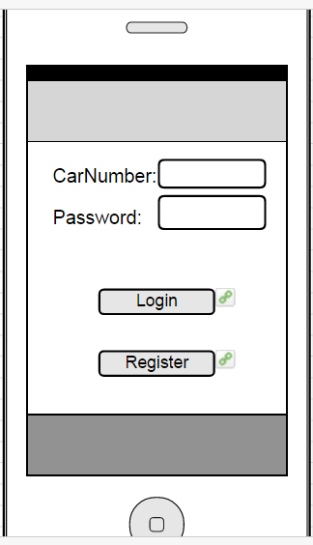

**Figure 1. Logging Page**

* 1. **Account Creation and Registration**

Click on Register button in Logging On page to create new account. To create a new account fill up all the fields with your personal data and set your password and Car Number. When you enter the details and click on Register button, all the details entered by you are saved in the database which are verified when you try to logon to the application. There is a reset button to clear all the data you entered when you wish to do so. Immediately after you click Register button you are navigated to Login page where you need to enter car number and password and enter home page.

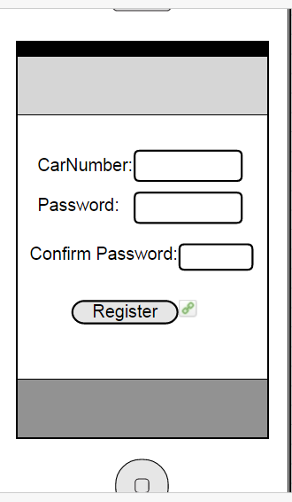

**Figure 2. Registration Page**

* 1. **System Menu**

Parking System Android application consists of 4 navigation menus. First is the

* + 1. **Home Page**

Home page helps user to navigate through different parking areas in the college. And also to check his account details. It helps to know about the available account balance he has to pay if he has any tickets raised against him.

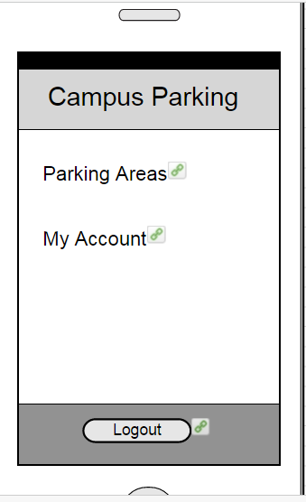

**Figure 3. Home Page**

* + 1. **Types Of Parking Page**

This page gives us the overview of different types of parking areas in the campus. If there is a particular parking area user is looking for, user can click on related parking area link, and then it will be redirected to a different page where user can check slots available in detail.

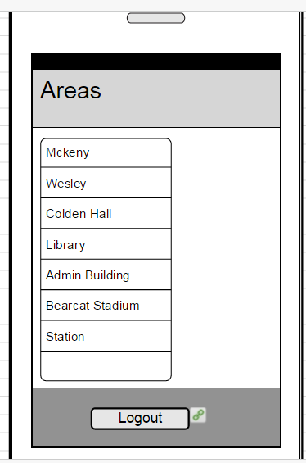

**Figure 4.Types of Parking Page**

* + 1. **Account Information Page**

Whenever user clicks on My Account then that will redirect to this page. In this user can check the current balance , balance due to be paid and last login details.

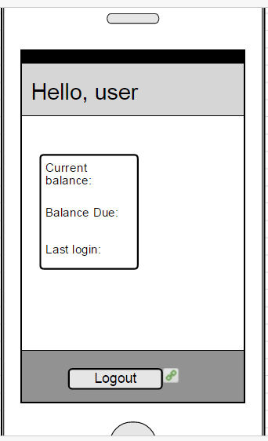

**Figure 5. Account Information Page**

* 1. **Exit System**

User can exit from application just by closing the application. The session is maintained for the particular user after he/she logs in. The session is lost only when the user clicks on the logout button.